Examples of questions for the exam of Intellectual Capital and Knowledge Systems 2007/2008

The exam will contain 6 questions. 5 questions are about the literature like the questions 1-2 in this example and one question will be about the empirical analyses with Stata like question 3 in this example.

Question 1

1a) From the perspective of human capital theory, why is good information about human capital needed?
1c) What information is needed for an investor in knowledge acquisition (e.g. a student) to make an optimal choice? (explain)
1d) While firms generally put buildings and machinery on the balance sheet, human capital is in general not incorporated. Please provide two reasons for not including human capital on the balance sheet and show why these objections do not hold for physical capital.

Question 2

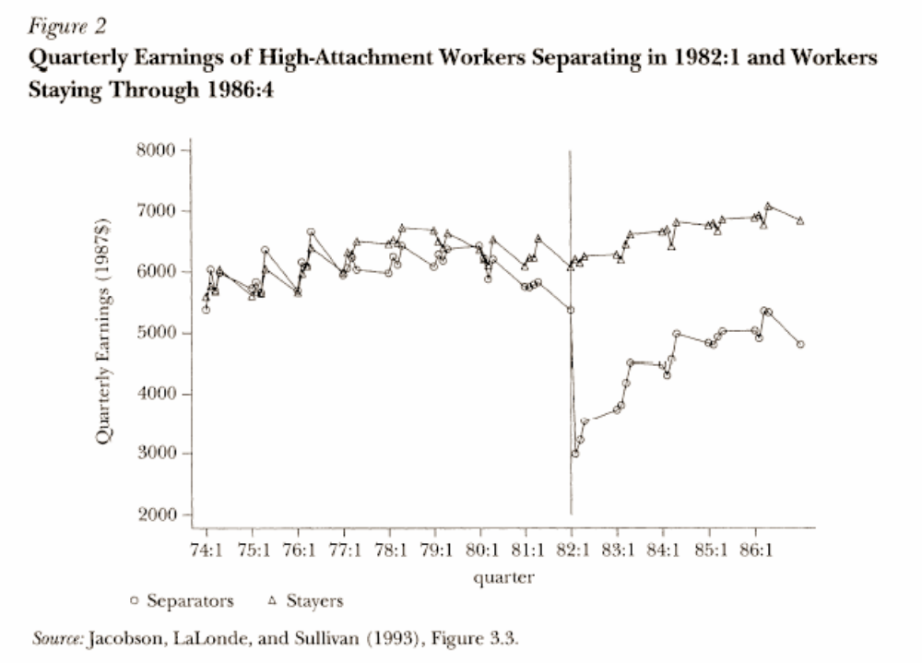

The figure shows the development of wages of a group of workers who are displaced and a group of workers who are not displaced (control group) in the first quarter of 1982.

2a) Why are the wages of displaced workers decreasing (compared to the control group) in the months before displacement?
2b) How does human capital theory explain the fall in income just after displacement?
2c) Why does the gap after displacement gradually diminish?

Question 3

This is a Stata-program a researcher used to investigate the growth of human capital over the life-cycle. The variables q_now and q_2 indicate the self-assessed performance of a worker compared to a worker who performs optimally in his job (This optimum equals 100) at the moment of the interview (q_now) and two years ago (q_2). Also a part of the output is provided below.

use 'ials.dta'.
keep if age>=25 & age<=65.
xi: reg literacy age sex i.country

Produces the following regression results:
Source SS df MS Number of obs = 18133
F( 16, 18116) = 323.86
Model 11855903 16 740993.934 Prob > F = 0.0000
Residual 41449580.9 18116 2288.00955 R-squared = 0.2224
Adj R-squared = 0.2217
Total 53305483.9 18132 2939.85682 Root MSE = 47.833

literacy Coef. Std. Err. t P>t [95% Conf. Interval]

age -.8889963 .0378997 -23.46 0.000 -.9632833 -.8147093
sex 9.220615 .7138135 12.92 0.000 7.821473 10.61976
USA .2165302 2.264777 0.10 0.924 -4.222648 4.655709
Netherlands 12.03967 2.230439 5.40 0.000 7.667795 16.41154
Poland -40.96551 2.333112 -17.56 0.000 -45.53863 -36.39238
Sweden 27.226 2.213432 12.30 0.000 22.88746 31.56454
Italy -13.87143 2.391619 -5.80 0.000 -18.55923 -9.183627
Norway 18.66335 2.125223 8.78 0.000 14.49771 22.82899
Slovenia -44.96931 2.423632 -18.55 0.000 -49.71986 -40.21876
Czech rep. -1.748402 2.280026 -0.77 0.443 -6.217469 2.720665
Denmark 1.951323 2.131559 0.92 0.360 -2.226735 6.129381
Finland 19.13146 2.242725 8.53 0.000 14.7355 23.52741
Hungary -31.98876 2.484245 -12.88 0.000 -36.85811 -27.1194
Canada 5.738852 2.232948 2.57 0.010 1.362061 10.11564
Switzerland -2.462954 2.149864 -1.15 0.252 -6.676891 1.750984
Chile -63.38703 2.339877 -27.09 0.000 -67.97341 -58.80065
_cons 311.5304 2.371779 131.35 0.000 306.8815 316.1793

4a) Explain the age coefficient from the perspective of the human capital theory.
4b) What do the results suggest about differences between men and women in the level of human capital? (explain)
4c) What results suggest about differences between countries in the level of human capital? (explain)
4d) How would you change the syntax if you wanted to regress the effect of literacy on wages, correcting for age, gender and country differences?

